How to Access BHSU Tutor.Com
Created on Sep 15, 2023 by Ezekiel Bucks
Go to Black Hills State University - Home
fi
VIEW PAGE →

Go to D2L
2
VIEW PAGE →
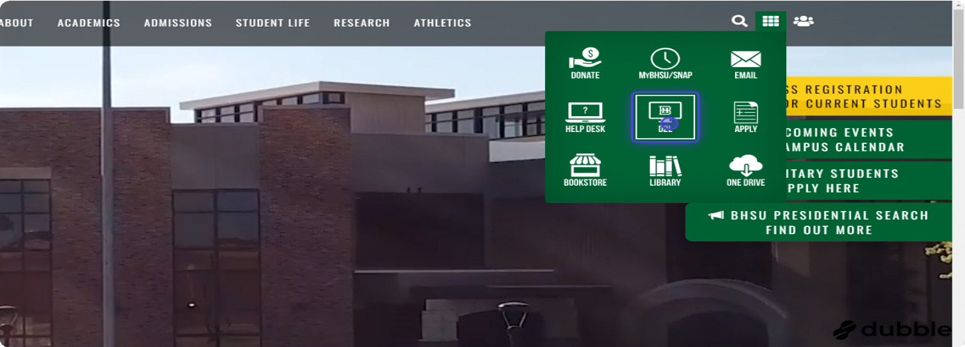

Click on the course you would like tutoring for
3
VIEW PAGE →
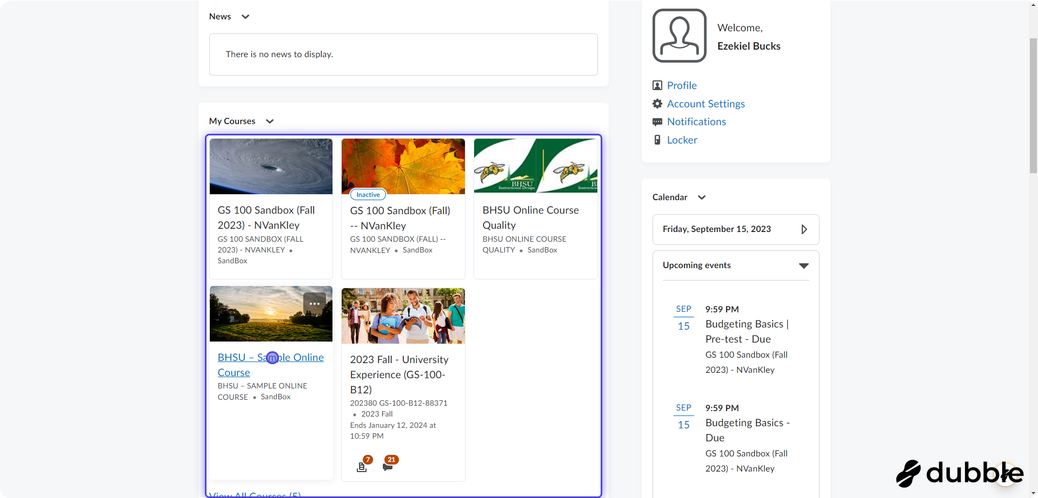

Once in the D2L course shell click on 'Help'
4
VIEW PAGE →
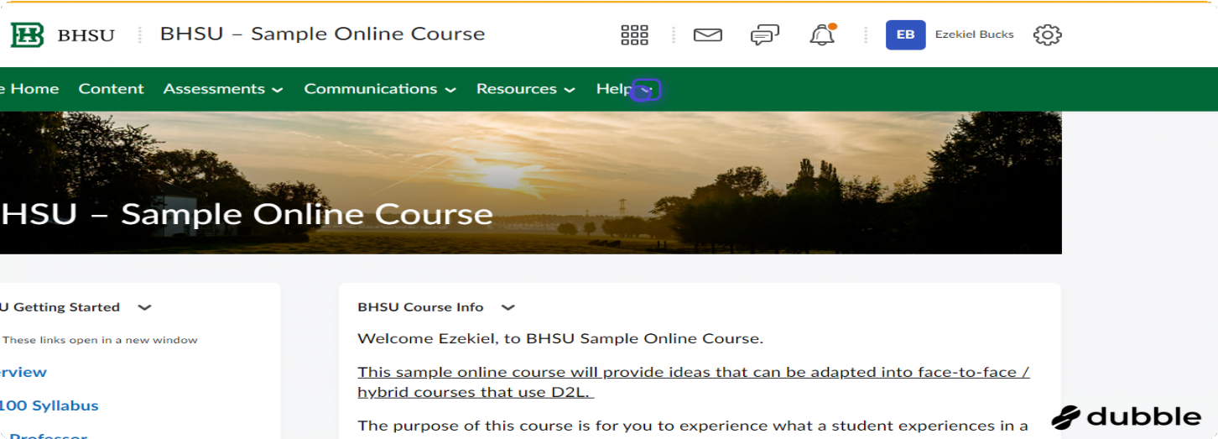

Select BHSU Tutor.com
5
VIEW PAGE →
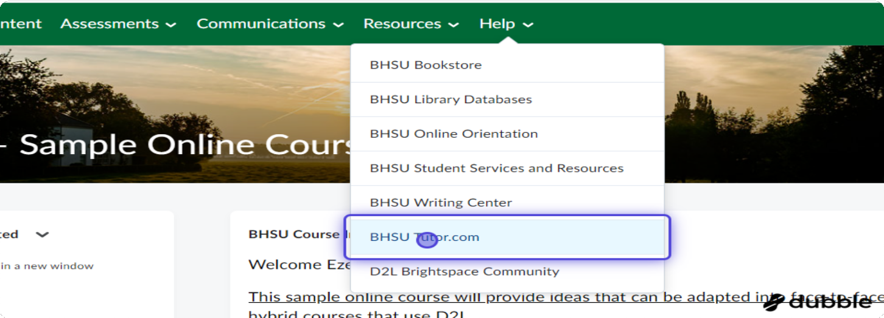

Click on 'Connect Now' to get connected with a tutor immediately
6
VIEW PAGE →
OR see step 11 if you want to schedule a later appointment with a tutor
You can also click writing review for help with a paper or click 'Take a Tour' to learn more about Tutor.com
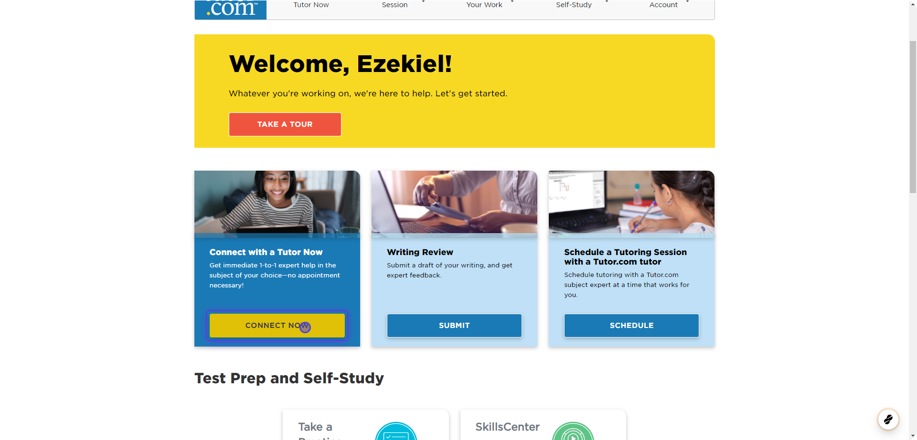

Select the 'Topic' that you need help with
7
VIEW PAGE →
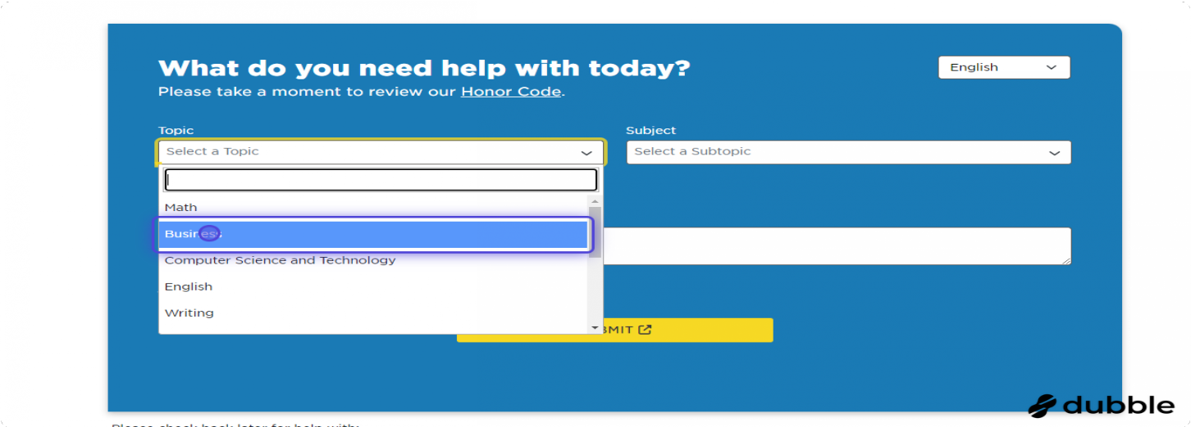

Select the 'Subtopic' that you need help with
8
VIEW PAGE →
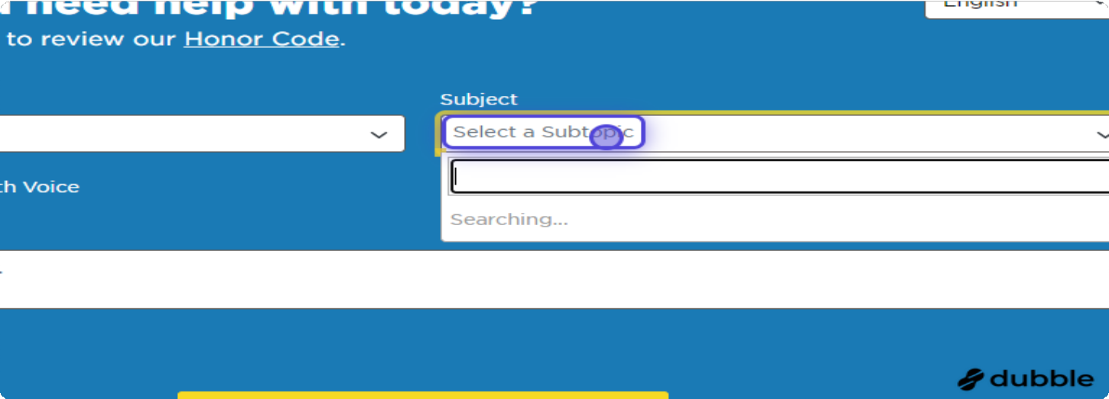

9 Briefly type in what you need help with
You can also chose if you want to just chat with a tutor or if you want chat with voice
You can also attach a file; this might be a previous test, an assignment prompt, or a written assignment that you need help with
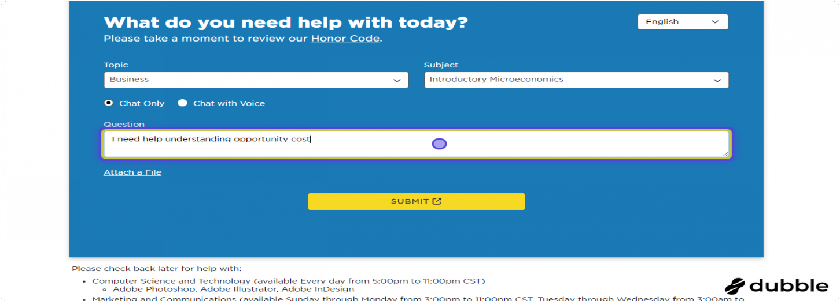

Click on SUBMIT
fiO
VIEW PAGE →
It may take a few minutes to connect with a tutor
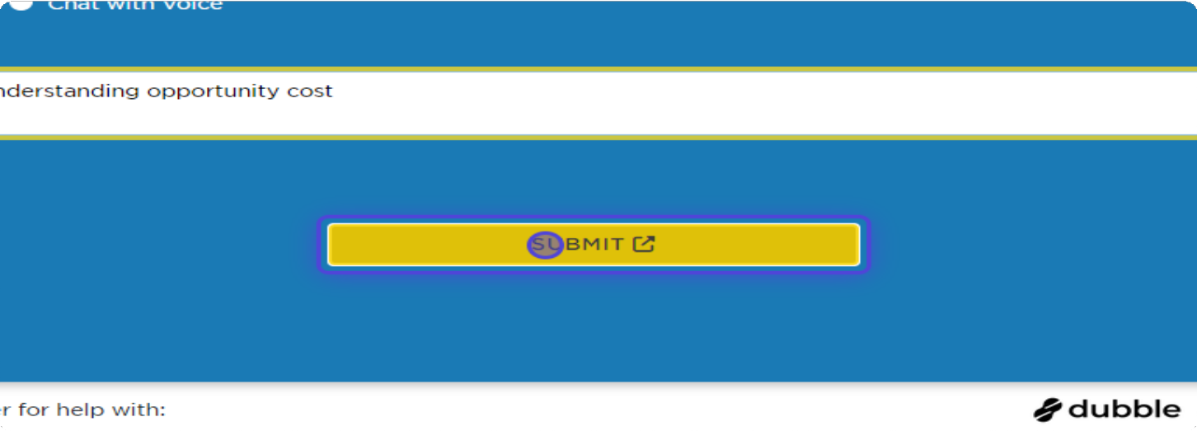

To make a future appointment with a tutor click on 'Schedule'
fifi
VIEW PAGE →

Select the subject you would like help with
fi2
VIEW PAGE →
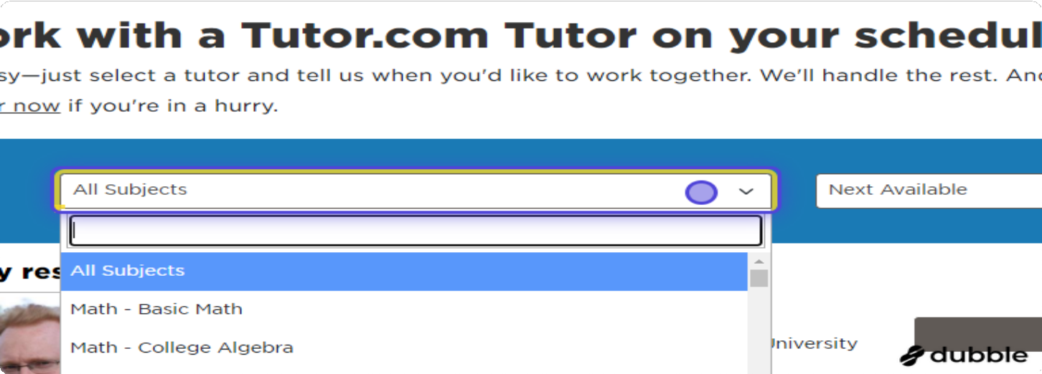

You can filter you search depending on your needs
fi3
VIEW PAGE →
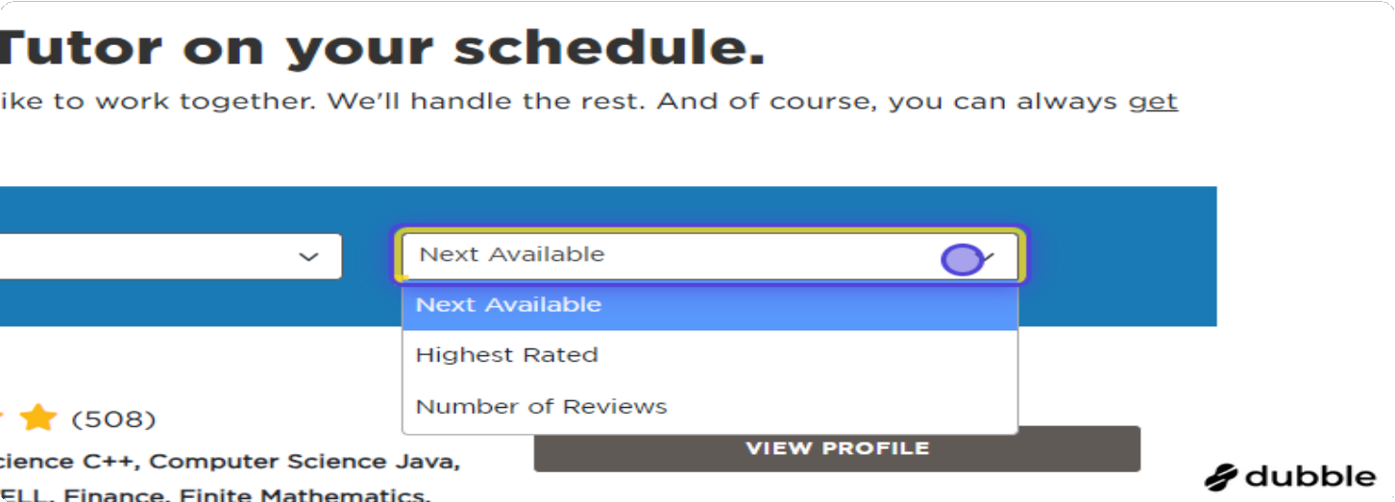

Click on SCHEDULE
fi4
VIEW PAGE →
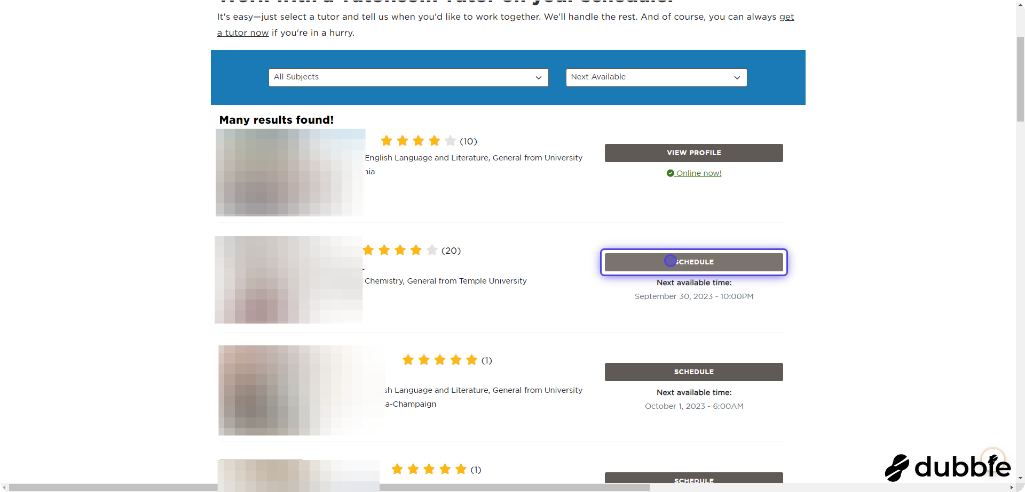

Fill out the scheduling information
fi5
VIEW PAGE →
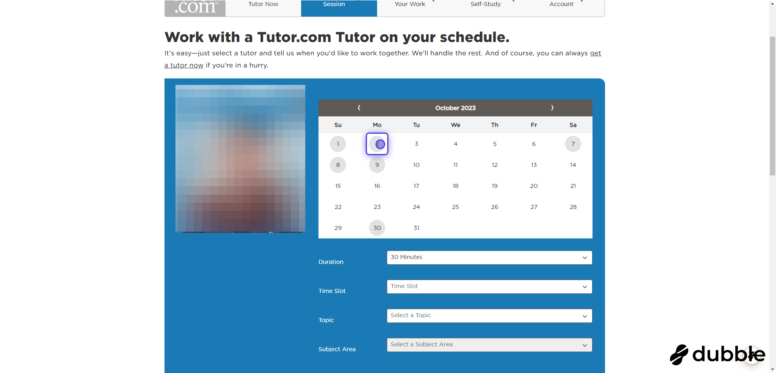

fi6 Let the tutor know what you need help with
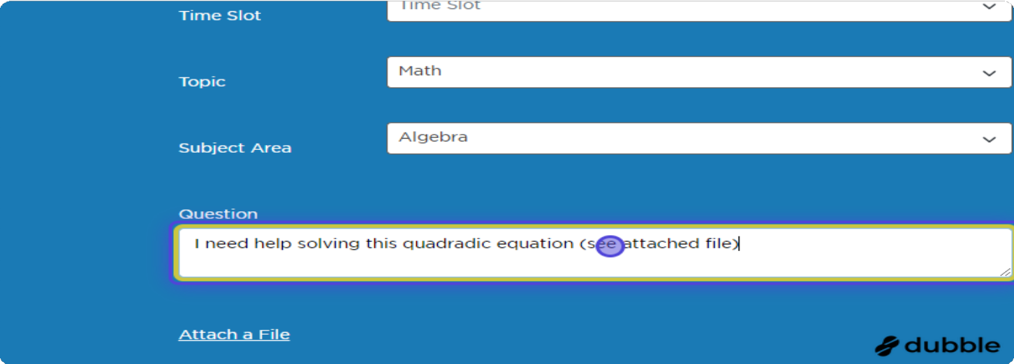

Click on 'Schedule Session'
fi7
VIEW PAGE →
You are now scheduled with a tutor--don't forget your appointment!
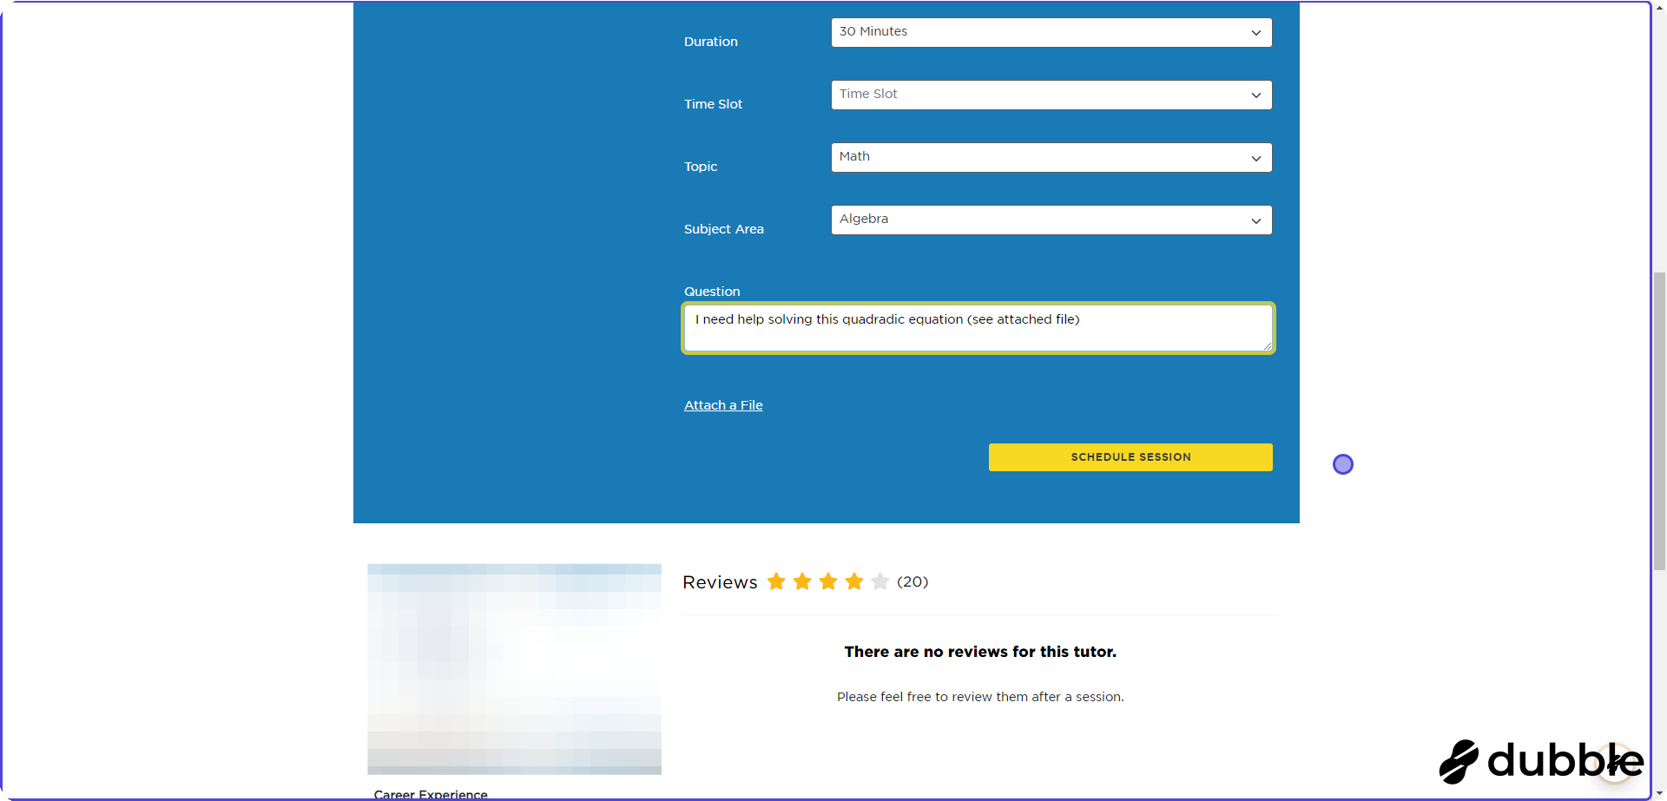

Page 9 of 9

